CIVIL PRQCEDURE CODE, 1908-II INCLUDING LINIITATIQUN ACT, 1963
(Paper-VII, Code: 507)
UNIT-I
Execution of Decree (Ss 36 to 50), Modes of Execution (Ss 51 to 54), Arrest and Detention (Ss 55 to 59 & O-21 Rules 37 to 40), Attachment of Property (Sse53 to 64), Sales of Attached Property (O-21Rules 64 to 69), Apportionment & misc. provisions (S70-73, & Ss to 152).
Leading Cases:
i) Hira Lal Patni v Sri Kali Nath AIR 1962 SC 199
ii) Smt Nirmla Gupta v Ravinder Kumar AIR 1996 MP 227
iii) ' Ram Saroop v Daljit Singh AIR 1995 Delhi 351
UNIT-II
Appeal from Original Decree (SS-96 to 99 & O 41), Appeal from Appellate Decree (Ss-100 to 103 & O 42),Appeal from Orders ( S-104 to 106 & O 43) Appeals by Indigent persons (O 44) Appeal to the Supreme Court (O-45).
Leading Cases: I _
i)Rarnchandra Pandurang Sonar v Murlidhar Ramchandra Sonar AIR 1990 SC 1973
ii)Smt Vidyavati v Sri Devi Dar AIR 1977 SC397.
UNIT-III:
Form and Grounds of Appeal, Procedure of hearing on admission of appeal, Cross objections & Cross appea1s, Remand, Production of additional evidence, Judgment and decree in appeal (O 41 R 1to3 7) Reference (S-113 & O-46) Review (S-114 & O-47),Revision (S. 115).
Leading Cases:
i) Major S.S.Khanna v Brig. FJ Dillon AIR 1964 SC 497.
ii) State of Maharashtra v Pitro AIR 1982 SC 1196.
iii) Ramchandra Pandurang Sonar v Murlidhar Ramchandra Sonar AIR 1990 SC 1973.
iv) Smt. vidyavati v Sri Devi Dar AIR 1977 SC 397
UNIT IV:
Limitations Act.
Objectives of the Act extent & commencement, S.1, Definitions, S-2, Limitation of Suits, Appeal and Application (SS 3-11), Computation of period of Limitation (Ss.-12 to 15) Effect of Death, fraud, acknowledgement and Payments etc. on Limitation (S. l6 to 22) Acquisition of Ownership by prescription (S 25-27).
Leading Cases:
i) Rare Lal v Rewa Coal Pieidslstd AIR 1962 361.
ii) lsalishatinathan Cotton Mills Co Ltd v 'The Alluminium Corp. of India AIR 1971 SC 1482.
Book Recommended:
Mulla - Code ot`Civil Procedure
C.K. Takwani - Civil Procedure I
DN. Mathur - The Code of Civil Procedure

PROPERTY LAW INCLUDING TRANSFER OF PROPERTY ACT AND EASEMENT ACT
(Paper-VIII, CODE No. 508)
UNIT-I Sections 1 to 35
Object and Scope of the Transfer of Property, l882, Interpretation Clause (Section-3), Definition of ‘Transfer' of Property, Subject Matter of Transfer, Persons competent to Transfer, oral Transfer, Transfer for the benefit of Unborn Person, Rule against Perpetuity, Vested and Contingent Interests, Conditional Transfer, Doctrine of Election.
leading Case:
- Kokilambal & Others V. N.Ra1nan, AIR 2000 SC 2468
- Indu Kakkar V Haryana Industrial Development Corporation Ltd. & another AIR 1999 SC 296
UNIT-II Sections 36 to 53-A
Apportionment, Transfer of Property by ostensible Owner (Section-41), Transfer by unauthorized Person who subsequently acquires Interest in Property Transferred, Transfer by One Co-owner, Joint Transfer for consideration, Priority of Rights created by Transfer, Fraudulent Transfer, Doctrine of Lis- Pendens, Doctrine of Part-Performance .
Leading Case:
- Rani Prasad V Rain Mohit Haaara & others AIR. 1967 SC 744
- Jumma masjit V Kodimaniandra Deviah AIR l962 SC S47
UNIT-III
Definition of Sale, Rights Liabilities of Buyer and Seller, Marshalling by Subsequent Purchaser, Definition of Mortgage and kinds of Mortgage (Section 58-59), Rights and Liabilities of Mortgagor (Section 60 to 66), Rights and Liabilities of mortgagee (Section 67 to 77), Priority (Section 78 to 80).
Leading Case:
- Seth Ganga Dhar V Shanker Lal & others AIR 1958 SC 773.
- Commissioner of IT V M/s Motors & General Store pvt. Ltd, AIR 1968 SC 200.
UNIT-V
Charge (Section 100) Definition or Lease, Rights and Liabilities of Lessor and lessee (section 105-108), Determination of Lease (Section 111), Gift (Section 122 to 129) .
Leading Case:
- Technician Studio Pvt. Ltd. V Lila Ghosh AIR I977 SC 2425 I `
- Sonia Bhatia V State of UP and Others ATR I 98l. SC l271t
Book Recommended:
DF Mulla - Transfer of Property Act.
Shah SM - Lectures of Transfer of Property.
Shukla SN - Transfer of Property.
LAhri SM - Transfer of Property.
Sinha SN - Transfer of Property.
Shukla VN - Transfer of Property.
Diwan Paras - Transfer of Property.
Tripathi GP - Transfer of Property.

Principal of Taxation Law (Paper – IX code 509)
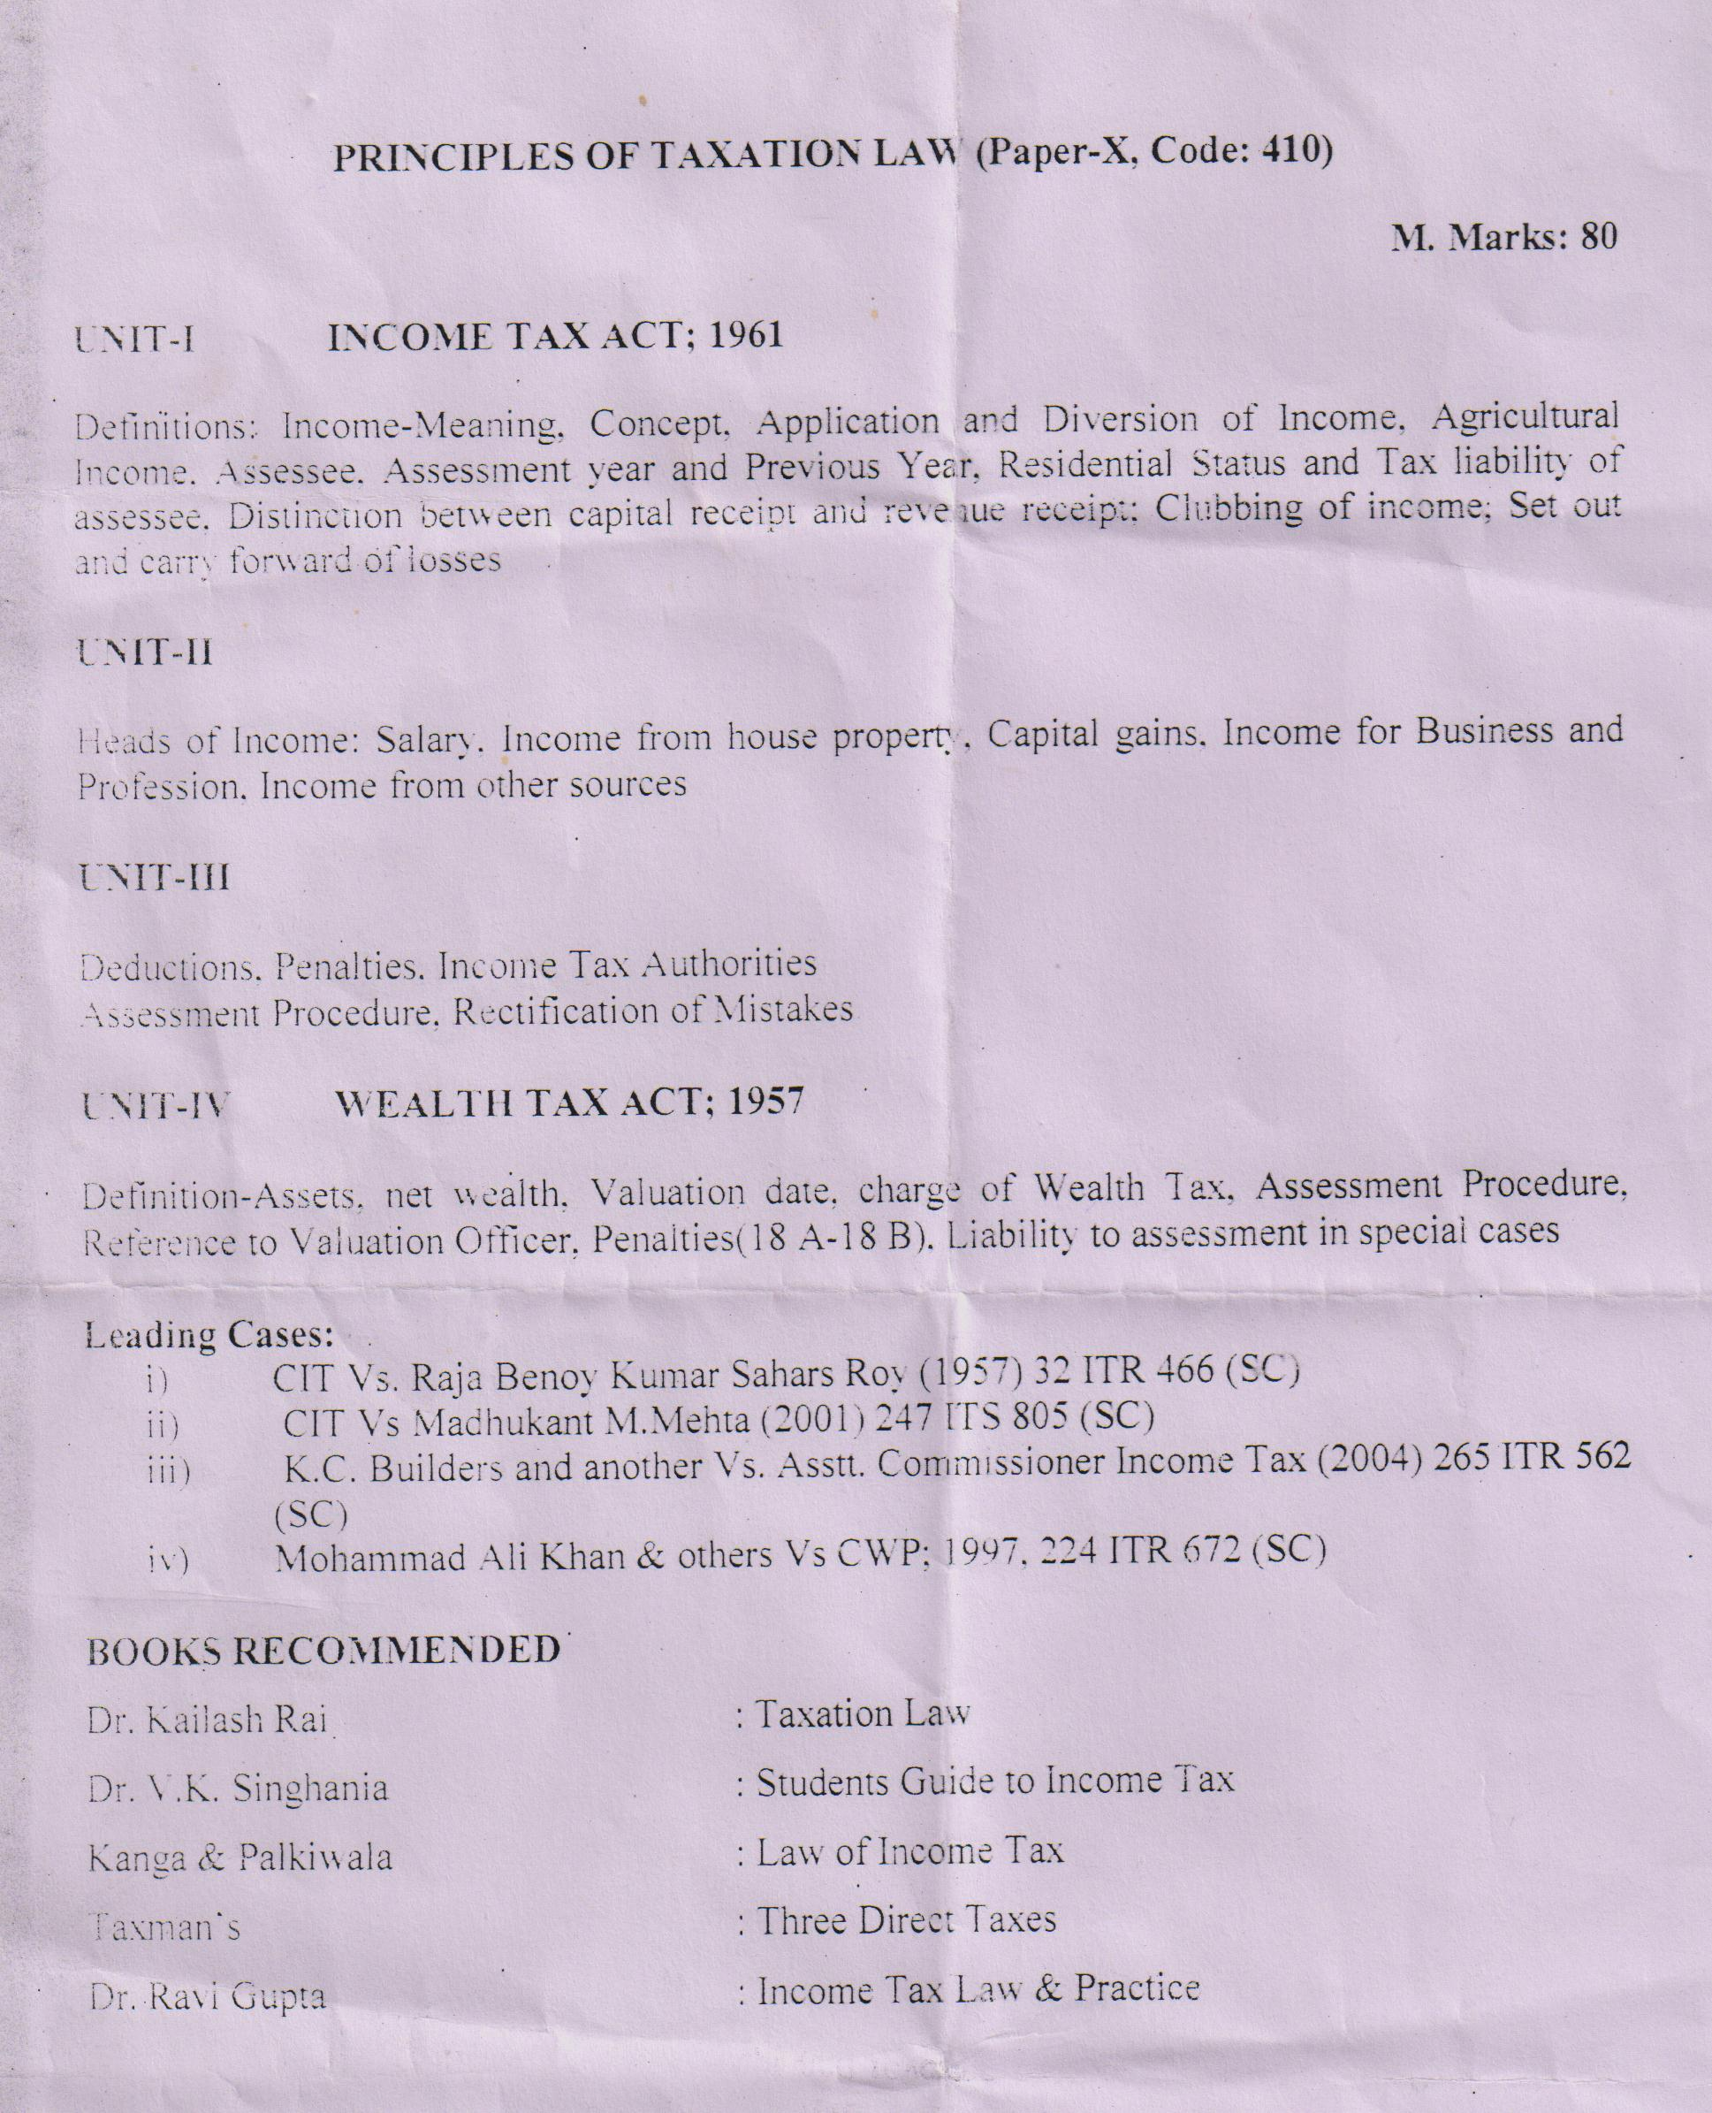

Insurance Law (Paper – X code 510 optional paper 6)
M.Marks: 80
Unit- 1
Definition, Nature and History of insurance, Concept of Insurance and Law of Contract, History of insurance, concept of insurance and law of contract, history and development of Insurance in India, Insurance Regulatory Authority-Role and Function, Contract of insurance, Classification of Contract of insurance, Nature of ‘various Insurance Contracts, principle of Good Faith-Non Disclosure, Misrepresentation in Insurance Contract, insurable Interest, The Risk.
UNIT -2
Nature and Scope of Life Insurance, Definition and Formation of Life Insurance Contract, event Insured against Life Insurance Contract, Circumstances Affecting the Risk, Amounts recoverable under Life Policy, Persons entitled to Payment.
UNIT-3
Nature and Scope of Marine Insurance, insurable interest, Insurable Value, Conditions, Express Warranties, Voyage-deviation, Perils of the Sea, Measure of Indemnity, Total Valuation Liability to third Parties, The Marine Insurance Act-I 963.
Unit- 4
Important Elements in Social Insurance, its need, commercial insurance and Social insurance. workmen Compensation-Scope, Risk Covered, Industrial accidents, Occupational diseases, cash Benefits, Incapacity, Amounts of compensation, Nature of Injuries, Dependents schedule, Public Liability Ins urance Act Scheme and Athorities.
Leading Case:
- M.B. Mehta ‘V. D..M Ram Chandra nayak AIR 1967SC 108
- Mitliiulal Vs LIC of India AIR 1962 SC 814
- General Assurance Society Ltd Vs. Chandanull Jain AIR 1966 SC 1644
- New India Assurance ltd Vs GN Sainani AIR 1997 SC 2938.
- National insurance ltd Vs. Winner ChoratesPvt. Ltd. 2003 (5 CLD 6 NC).
Books Recommended:
MN Mishra - Principles of insurance and practices
MN Mishra - Principles and Insurance.
CR Rao - Treaties on the Law of Insurance.
Brij Nandan Singh - Insurance Law
RM Ray - Life Insurance in India
Avtar singh - Law of Insurance.

DRAFTING PLEADING AND CONVEYANCING
Paper-XI (Code No. 511) CLINICAL COURSE-1
M.Marks: 100
Unit -1 Drafting
General Principal of Drafting, Kinds of Deeds, Drafting of Writ Petition, Drafting of PIL cases, Drafting of Execution petition, drafting of appeal, drafting of revision and writ petition.
Unit -2
Ciivii Pleading preparation of Plaint, Preparation & Pleading of Written Statement, inter locutary order and Applications, affidavit, Execution Petition, Preparation of memorandum of appeal, criminal complaint, Bail Application & Anticipatory Bail Application, Petition under Hindu Marriage Act, Petition under Motors Vehicle Act.
UNIT-3: CONVEYANCING
Sale deed, Mortgage Deed, Lease Deed, Gift Deed, Power of Attorney (General And Special), Will, Notice.
Unit-4
Note: The Course will be taught class instructions and simulation exercises, preferably with assistance of practicing lawyers/retired judges.
Apart from teaching the relevant provisions of law, the course may include not less than 15 practical exercises in drafting carrying a total of 45 marks 3 marks for each and 15 exercises in conveyancing carrying another 45 marks 3 marks for each exercise) remaining 10 marks will be given for viva-voce.
Note: The panel of examiners for evaluation shall cosist of the chair person, one external expert and one internal expert to be appointed by the chairperson. Presence of any two members shall constitute the corum.
Book Recommended:
Monga PC - the law of pleading in India
Chaturvedi RN - Pleading Drafting and conveyancing (Central Law Publication)
Chatuvedi AN - Drafting Pleading and conveyancing.

MOOT COURT EXERCISE AND INTERNSHIP
PAPER XI (Code -511) CLINICAL COURSE-IV
Max. Marks: 100
COMPENENTS OF THE PAPER
- MOOT COURT: 30 Marks
Every student will be required to do at least three moot courts with 10 marks each. The moot court work will be on assigned problem and it will be evaluated for 5 Marks for written material and 5 marks for oral Advocacy.
- OBSERVANCE OF TRIAL (CIVIL AND CRIMINAL : 30 Marks

Students will be required to attend at least two trials one Civil and one Criminal in Courts within assigned period. They will maintain a record and enter the various steps observed during their attendance on different days in the court assignment.
- INTERVIEWING TECHNIQUES AND PRE-TRIAL PREPARATIONS AND INTERN SHIP DIARY: Marks30
Within assigned period, each student will observe two interviewing sessions of clients at the Lawyers’ office/Legal Aid Office and record the proceedings in a diary which will carry 15 marks. Each student will further observe the preparation of documents and court papers by the Advocate and the procedure of filing the suit/petition. This will be recorded in the diary, which will carry 15 marks.
- THE FOURTH COMPONENT OF THIS PAPER WILL BE VIVA-VOCE EXAMINATION ON ALL THE ABOVE FOUR ASPECTS.
This will carry I0 Marks.
INTERNSHIP: Each registered students shall have to complete minimum of twelve weeks internship for 3 year course stream and internship in any year shall not be more than four weeks in a year. Each student shall keep internship diary which shall be evaluated in the final semester of the courses.
Note: A Panel of examiners shall evaluate the performance of the students consisting of Chairperson. An External Expert and internal expert to be by the Chairperson and the presence of two members shall constitute the quorum.
BOOKS RECOBIMQENDED:
Dr. Kailash Rai : Moot Court, Pre-Trial Preparations & participation in Trial (Central Law Publication)
Prof S.K awasthi : Practical Training of Law. Moot Court & Viva-Voce (Agra Law Agency)
R.N. Chaturvedi : Pleadings, Drafting & Conveyancing (Central Law Publications)
The Advocate Act 1971
The Legal Services Authorities Act, I98?
Indian Penal Code, 1860
Code of Criminal Procedure, 1973
The Indian Evidence Act, 1872
Code of Civil Procedure, 1908

